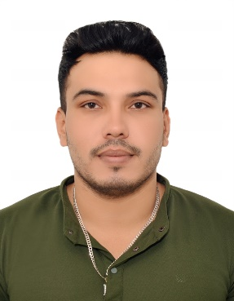

Riyaj Malek

Bike Messenger cum PRO

Sharjah, UAE

Mobile: +971 54 432 9835

Email. tahirmalek2016@gmail.com

Objective
Motorbike Messenger with over 4 years of experience in high-volume package delivery in urban environments. Proven ability to consistently navigate and deliver items within tight deadlines while maintaining a flawless log of all deliveries. Demonstrated expertise in optimizing routes, maintaining motorbikes, and communicating effectively with dispatchers and teams.
Work Experience
Royal City Building Maintenance, Sharjah (01/04/2022 to Present)
- Received & Deliver Documents, Office Equipment, Cash and Cheque Deposit at Bank
- Purchasing Building Materials and tools, Finding Quotation with Samples as per requirements
- Deliver Materials to Technician from Store and Help to Buy Materials in Emergency

City Properties Real Estate, Sharjah (01/07/2020 to 30/06/2022)

- Received & Deliver Documents, Receipt Voucher, Cash and Cheque Collection and Submitting at Office, Bank Deposit
- Residents Contract Renewal, Trade License Renewal, Sewa Application, Visa Application,

Najm al Seen Marble LLC (01/07/2016 to 30/06/2020)

- Managing Store Inventory, Machine and Toos
- Collecting Orders and Managing Delivery on Time
- Supervising Labor to manage workload

Key skills & Competencies

- Honest, reliable, trustworthy, respectful, adaptable, and professional at all times. Able to communicate Skills present confidently, clearly, and expressively.
- Accustomed to working with senior management.
- Always be a good team player, data collection and ordering. Willing to take jobs to balance the team workload.
- Listening and able to communicate well with people of all levels.
- Attention to detail, accuracy, and customer service orientation.

Education

- 12th Pass (Gujarat Secondary Education Board)

Passport Details
Passport Number : Y 1752429
Date of Issue : 30/05/2024
Date of Expiry : 29/05/2034

Personal Details

Name : Riyajbhai Salimbhai Malek
Date of Birth : 11/04/1994
Place of Birth : Gujarat (India)
Gender : Male
Marital Status : Married
Nationality : Indian
Language known : English, Hindi, Urdu, Arebic and Gujarati

